Methods in Document Object

<html>

    <head>

        <title>Methods in Document Object</title>

    </head>

    <body onclick="myFunction()">

        <script>

            function myFunction()

            {

                const element=document.activeElement.tagName;

                document.getElementById("demo").innerHTML=element;

            }

        </script>

        <h2>Active Element Property</h2>

        <input type="text" value="Input Field">

        <button>Click</button>

        <p>click anywhere on this page.</p>

        <p id="demo"></p>

    </body>

</html>

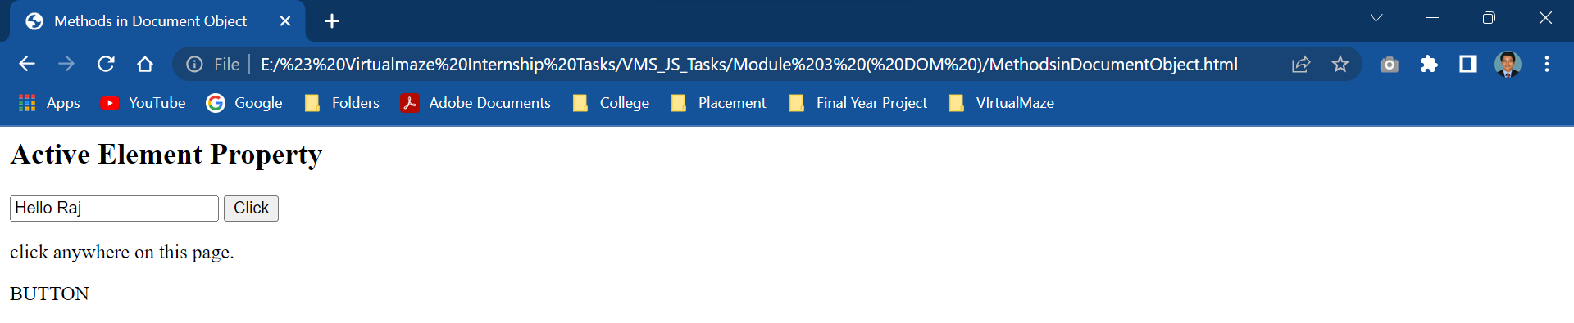

<html>

    <head>

        <title>Methods in Document Object</title>

    </head>

    <body>

        <script>

            function myFunction()

            {

                document.getElementById("demo").innerHTML="Hello Raj";

            }

            document.addEventListener("click",myFunction);

        </script>

        <h2>AddEventListener() Method</h2>

        <p id="demo">Click anywhere in the page to display "Hello Raj"</p>

    </body>

</html>

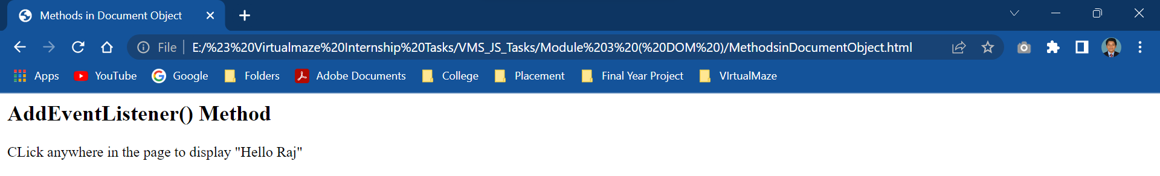

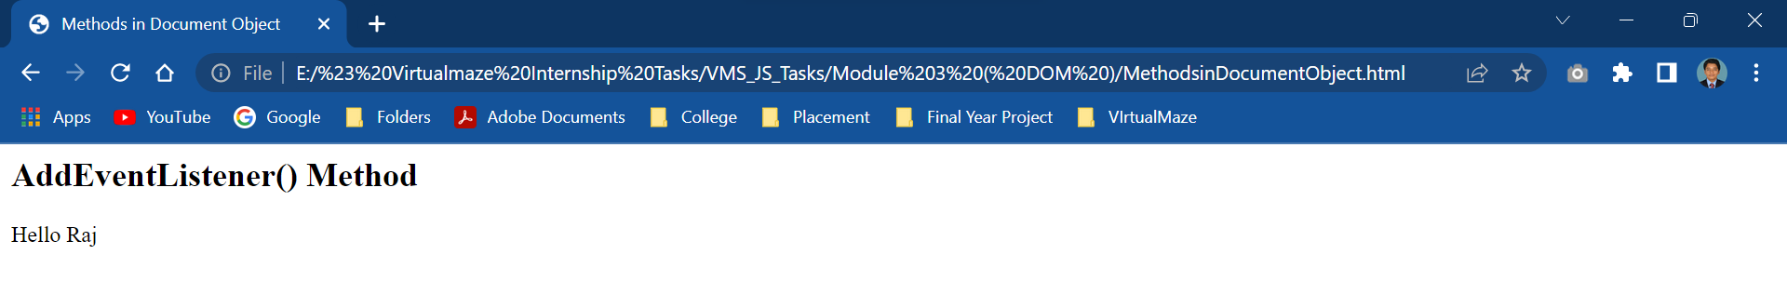

<html>

<body>

<h1>The Document Object</h1>

<h2>The getElementById() Method</h2>

<p id="demo"></p>

<script>

document.getElementById("demo").innerHTML = "Hello World";

</script>

</body>

</html>

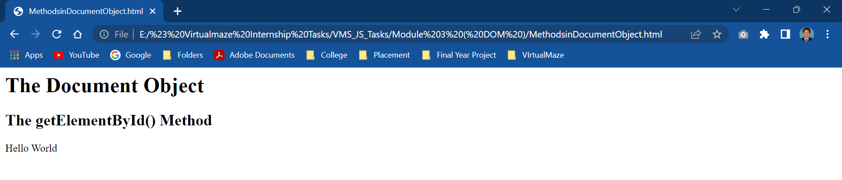

<html>

<body>

<h1>The Document Object</h1>

<h2>The lastModified Property</h2>

<p>This document was last modified:</p>

<p id="demo"></p>

<script>

let text = document.lastModified;

document.getElementById("demo").innerHTML = text;

</script>

</body>

</html>

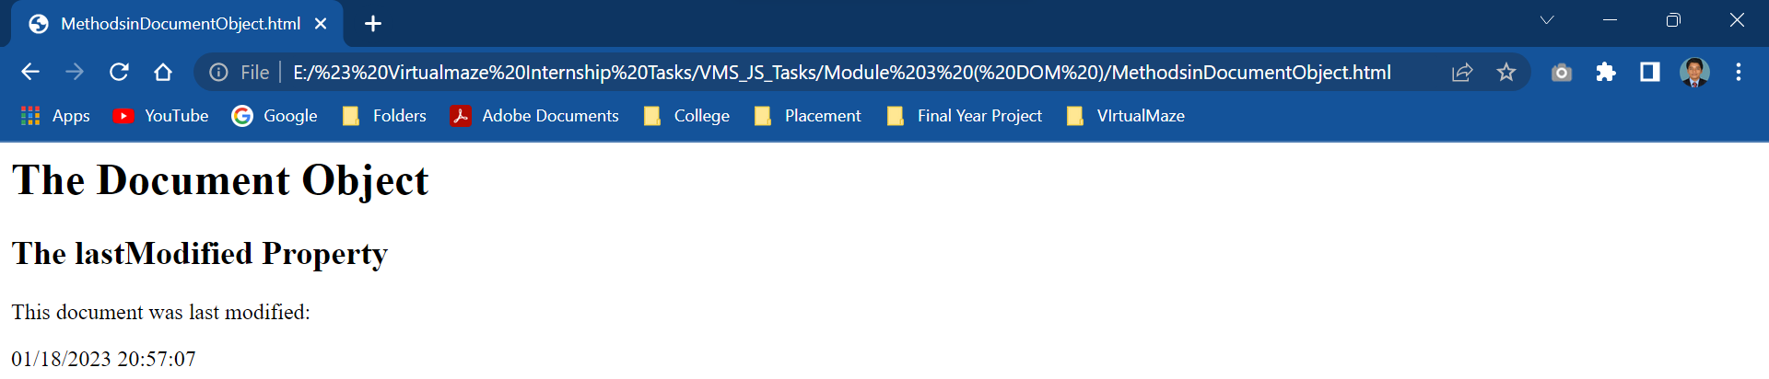

<html>

<body>

<h1>The Document Object</h1>

<h2>The querySelector() Method</h2>

<p>Add a background color to the first element with class="example":</p>

<p class="example">Hello Raj</p>

<p class="example">How are you</p>

<script>

document.querySelector(".example").style.backgroundColor = "red";

</script>

</body>

</html>

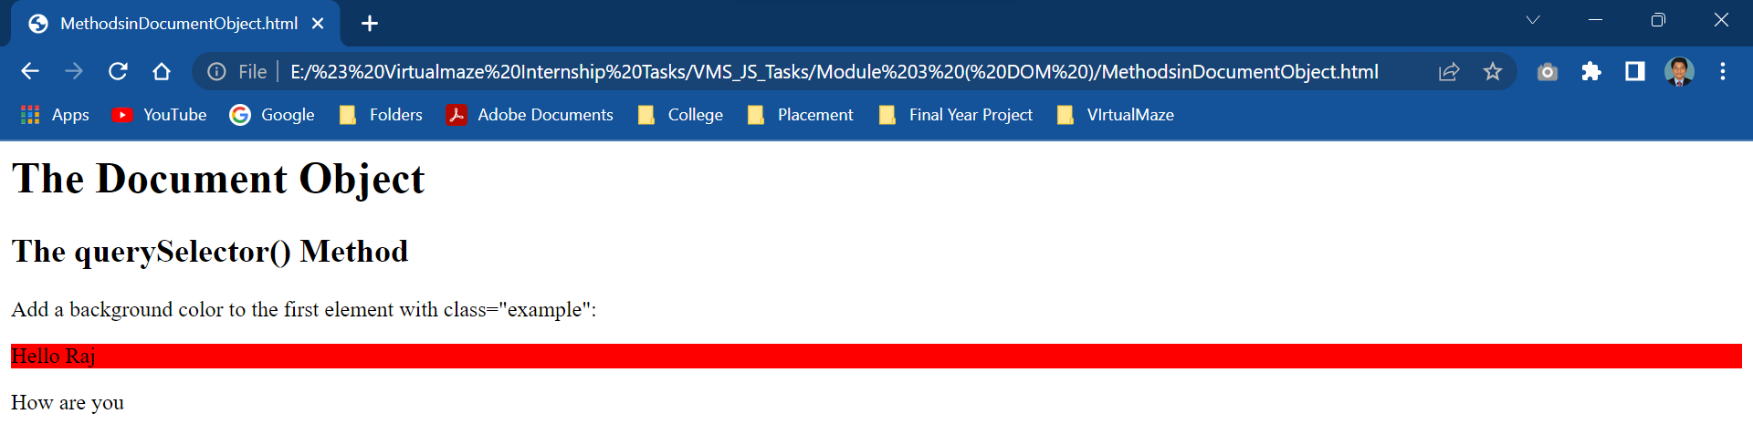

<html>

<body>

<h1>The Document Object</h1>

<h2>The querySelectorAll() Method</h2>

<p>Add a background color all elements with class="example":</p>

<h2 class="example">A heading</h2>

<p class="example">A paragraph.</p>

<script>

const nodeList = document.querySelectorAll(".example");

for (let i = 0; i < nodeList.length; i++) {

  nodeList[i].style.backgroundColor = "red";

}

</script>

</body>

</html>

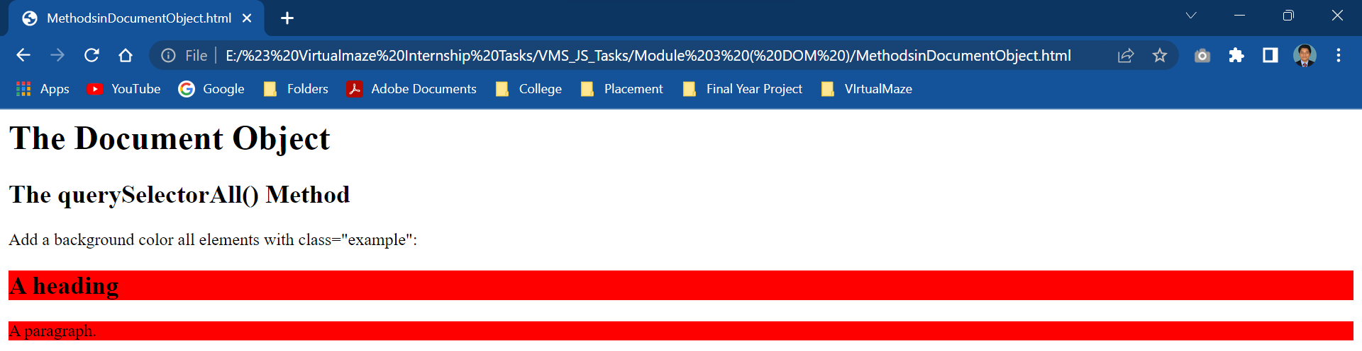

<html>

<body>

<h1>The Document Object</h1>

<h2>The write() and writeln() Methods</h2>

<p>write() does NOT add a new line (CR) after each statement.</p>

<p>writeln() DOES add a new line (CR) after each statement.</p>

<pre>

<script>

document.write("Hello World!");

document.write("Have a nice day!");

document.write("<br>");

document.writeln("Hello World!");

document.writeln("Have a nice day!");

</script>

</pre>

<p>It makes no sense to use writeln() in HTML.</p>

<p>Carriage return (CR) is ignored in HTML.</p>

</body>

</html>

